**FORMLABS SOP V1.1**

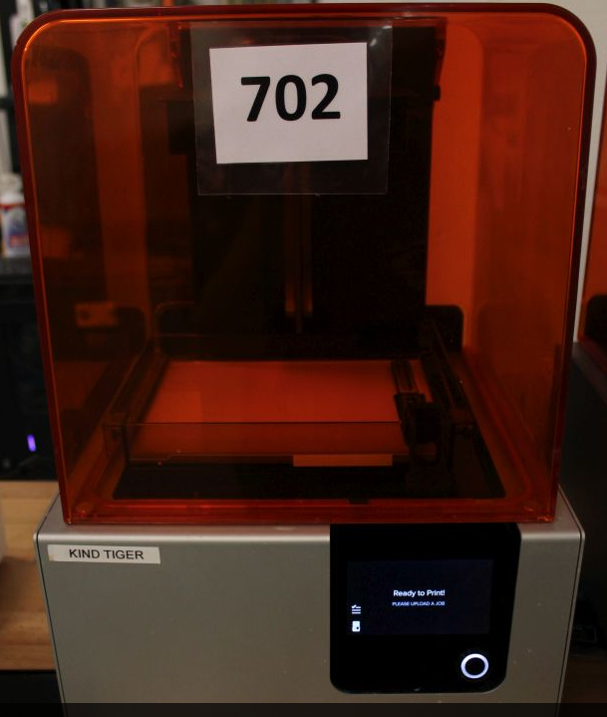

This SOP will guide you through the process of 3D printing on Formlabs printers ONLY. If you are not sure of anything having to do with this printer, STOP AND SEEK CLARIFICATION. Please follow all safety and PPE (personal protective equipment) recommendations.

You are expected to clean up after each and every use. You are expected to help maintain the station if you ever use it.

**Tools you’ll need:**

1. Safety glasses
2. Latex or nitrile gloves
3. Preform nesting software
4. Formlabs Form2 printer
5. Silicone spatula
6. Paper towels
7. 91% Isopropyl alcohol
8. Strainer
9. 16 oz plastic cups
10. Putty knife / removal tool
11. Shop rags
12. Formlabs cure box
13. Alcohol bath setup
14. Timer

See photos for reference.

**Layout**

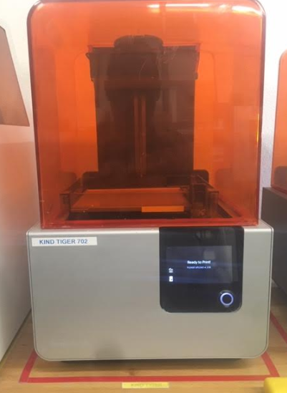 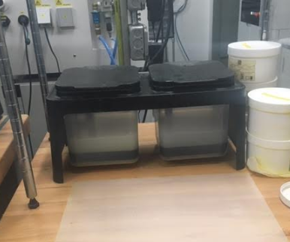

POST PROCESSING STATION

ALCOHOL BATHS

FORMLABS - KIND TIGER

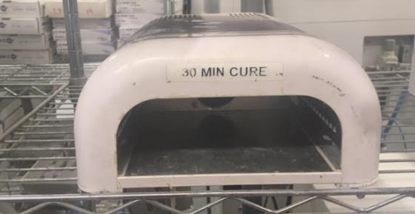 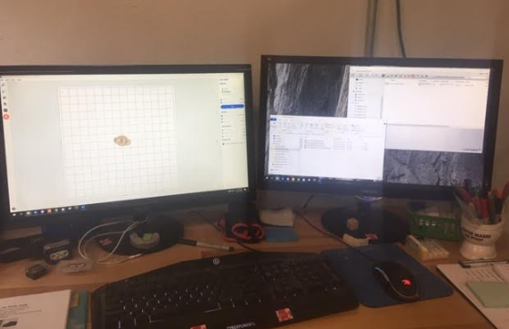

3D PRINTER WORKSTATION

FORMLABS – LIGHT CURE

**Gloves and safety glasses should be worn throughout the process both for contamination prevention and safety.**

**What NOT to do:**

**Do NOT** put any other material in the alcohol baths or risk unintended chemical reactions.

(See SDS located online for isopropyl bath)

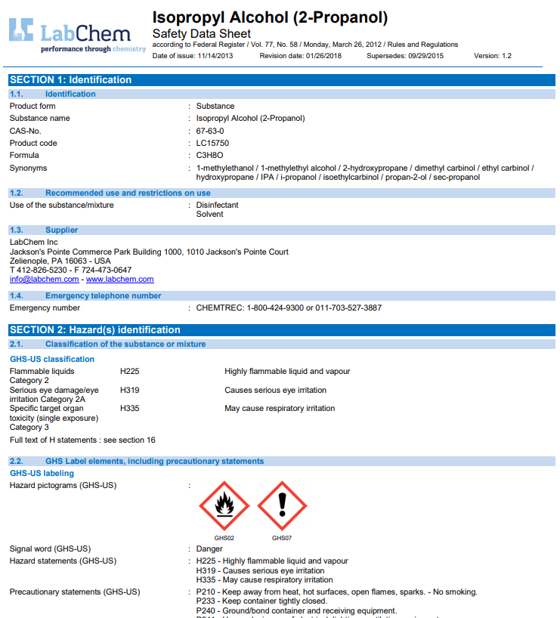

In conclusion, the steps to excellence are as follows:

* Keep everything CLEAN
* WORK SAFE ***and FOLLOW THE PROCEDURE***